

AP® Physics C
1994 Free response Questions

The materials included in these files are intended for use by AP teachers for course and exam preparation in the classroom; permission for any other use must be sought from the Advanced Placement Program®. Teachers may reproduce them, in whole or in part, in limited quantities, for face-to-face teaching purposes but may not mass distribute the materials, electronically or otherwise. These materials and any copies made of them may not be resold, and the copyright notices must be retained as they appear here. This permission does not apply to any third-party copyrights contained herein.

These materials were produced by Educational Testing Service® (ETS®), which develops and administers the examinations of the Advanced Placement
Program for the College Board. The College Board and Educational Testing Service (ETS) are dedicated to the principle of equal opportunity, and their
programs, services, and employment policies are guided by that principle.

The College Board is a national nonprofit membership association dedicated to preparing, inspiring, and connecting students to college and opportunity.
Founded in 1900, the association is composed of more than 4,200 schools, colleges, universities, and other educational organizations. Each year, the
College Board serves over three million students and their parents, 22,000 high schools, and 3,500 colleges, through major programs and services in
college admission, guidance, assessment, financial aid, enrollment, and teaching and learning. Among its best-known programs are the SAT®, the
PSAT/NMSQT®, and the Advanced Placement Program® (AP®). The College Board is committed to the principles of equity and
excellence, and that commitment is embodied in all of its programs, services, activities, and concerns.

APIEL is a trademark owned by the College Entrance Examination Board. PSAT/NMSQT is a registered trademark jointly owned by the College Entrance Examination Board and the National Merit Scholarship Corporation. Educational Testing Service and ETS are registered trademarks of Educational Testing Service.
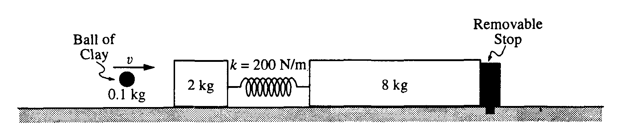
1994M1. A 2-kilogram block and an 8-kilogram block are both attached to an ideal spring ( for which k = 200 N/m) and both are initially at rest on a horizontal frictionless surface, as shown in the diagram above.
In an initial experiment, a 100-gram (0.1 kg) ball of clay is thrown at the 2-kilogram block. The clay is moving horizontally with speed v when it hits and sticks to the block. The 8-kilogram block is held still by a removable stop. As a result, the spring compresses a maximum distance of 0.4 meters.
a. Calculate the energy stored in the spring at maximum compression.
b. Calculate the speed of the clay ball and 2-kilogram block immediately after the clay sticks to the block but before the spring compresses significantly.
c. Calculate the initial speed v of the clay.

In a second experiment, an identical ball of clay is thrown at another identical 2-kilogram block, but this time the stop is removed so that the 8-kilogram block is free to move.
d. State whether the maximum compression of the spring will be greater than, equal to, or less than 0.4 meter. Explain briefly.
e. State the principle or principles that can be used to calculate the velocity of the 8-kilogram block at the instant that the spring regains its original length. Write the appropriate equation(s) and show the numerical substitutions, but do not solve for the velocity.
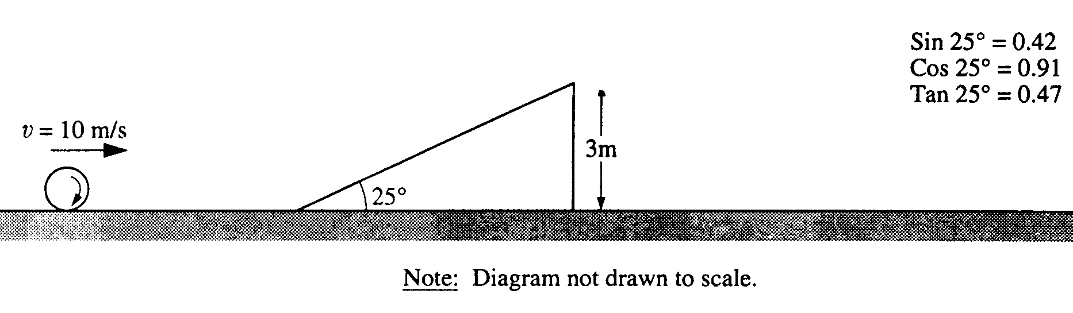
1994M2. A large sphere rolls without slipping across a horizontal surface. The sphere has a constant translational speed of 10 meters per second, a mass m of 25 kilograms, and a radius r of 0.2 meter. The moment of inertia of the sphere about its center of mass is I = 2mr²/5. The sphere approaches a 25° incline of height 3 meters as shown above and rolls up the incline without slipping.
a. Calculate the total kinetic energy of the sphere as it rolls along the horizontal surface.
b. i. Calculate the magnitude of the sphere's velocity just as it leaves the top of the incline.
ii. Specify the direction of the sphere's velocity just as it leaves the top of the incline.
c. Neglecting air resistance, calculate the horizontal distance from the point where the sphere leaves the incline to the point where the sphere strikes the level surface.
d. Suppose, instead, that the sphere were to roll toward the incline as stated above, but the incline were frictionless. State whether the speed of the sphere just as it leaves the top of the incline would be less than, equal to, or greater than the speed calculated in (b). Explain briefly.
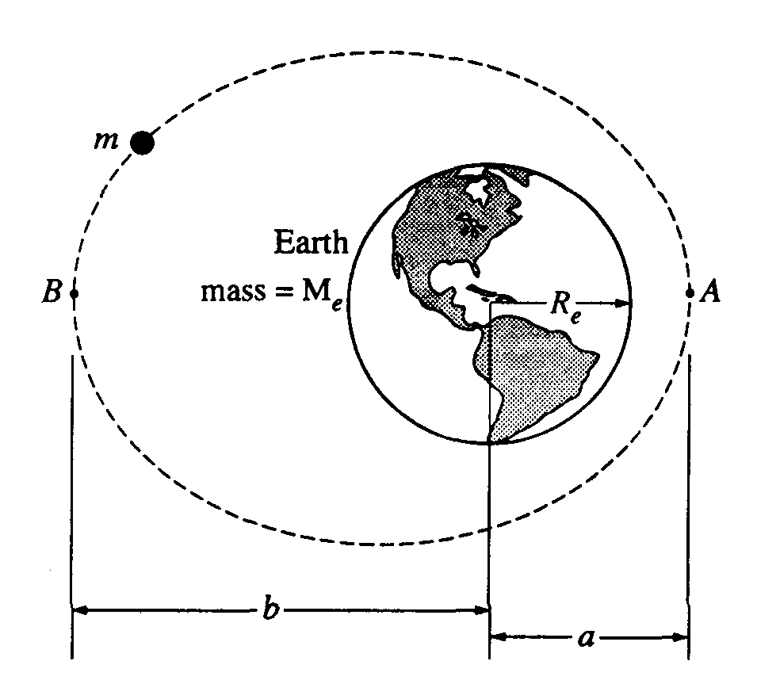
1994M3. A satellite of mass m is in an elliptical orbit around the Earth, which has mass M_{e} and radius R_{e}. The orbit varies from closest approach of a at point A to maximum distance of b from the center of the Earth at point B. At point A, the speed of the satellite is v_{o} Assume that the gravitational potential energy U_{g} = 0 when masses are an infinite distance apart. Express your answers in terms of a, b, m, M_{e}, R_{e}, v_{o}, and G.
a. Write the appropriate definite integral, including limits, that can be evaluated to show that the potential energy of the satellite when it is a distance r from the center of the Earth is given by

U_{g} = -Gm_{e}m
r

b. Determine the total energy of the satellite when it is at A.
c. What is the magnitude of the angular momentum of the satellite about the center of the Earth when it is at A ?
d. Determine the velocity of the satellite as it passes point B in its orbit.
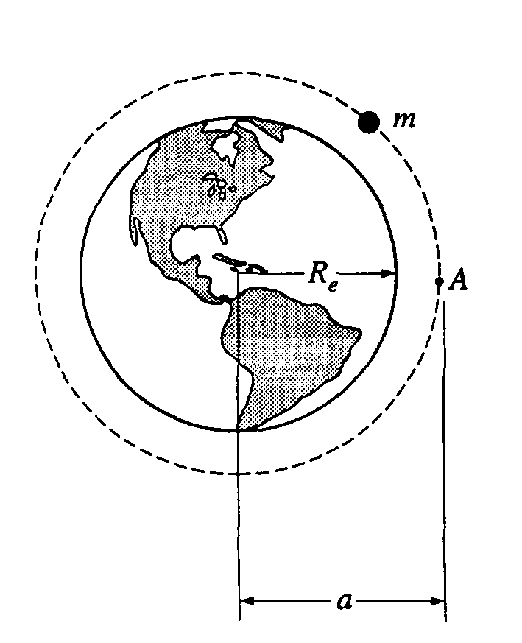
As the satellite passes point A, a rocket engine on the satellite is fired so that its orbit is changed to a circular orbit of radius a about the center of the Earth.
e. Determine the speed of the satellite for this circular orbit.
f. Determine the work done by the rocket engine to effect this change.
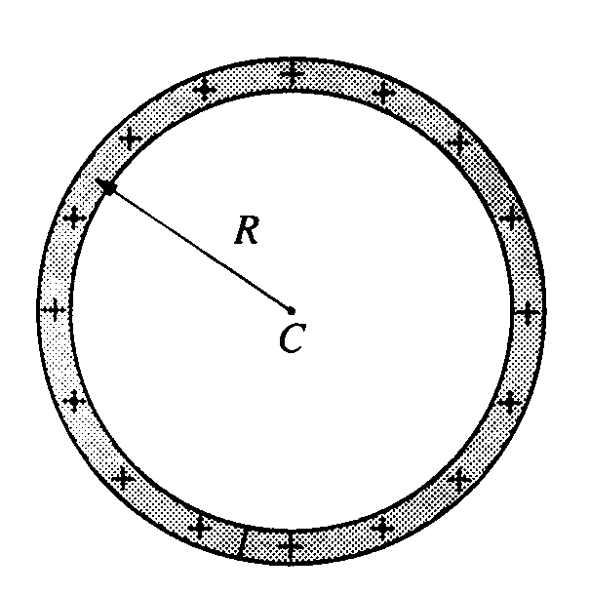
1994E1. A thin nonconducting rod that carries a uniform charge per unit length of λ is bent into a circle of radius R. as shown above. Express your answers in terms of λ, R. and fundamental constants.
a. Determine the electric potential V at the center C of the circle.
b. Determine the magnitude E of the electric field at the center C of the circle.

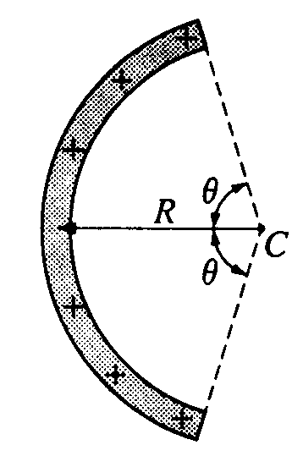
Another thin nonconducting rod that carries the same uniform charge per unit length λ is bent into an arc of a circle of radius R. which subtends an angle of 2R, as shown above. Express your answers in terms of λ and the quantities given above.
c. Determine the total charge on the rod.
d. Determine the electric potential V at the center of curvature C of the arc.
e. Determine the magnitude E of the electric field at the center of curvature C of the arc. Indicate the direction of the electric field on the diagram above.

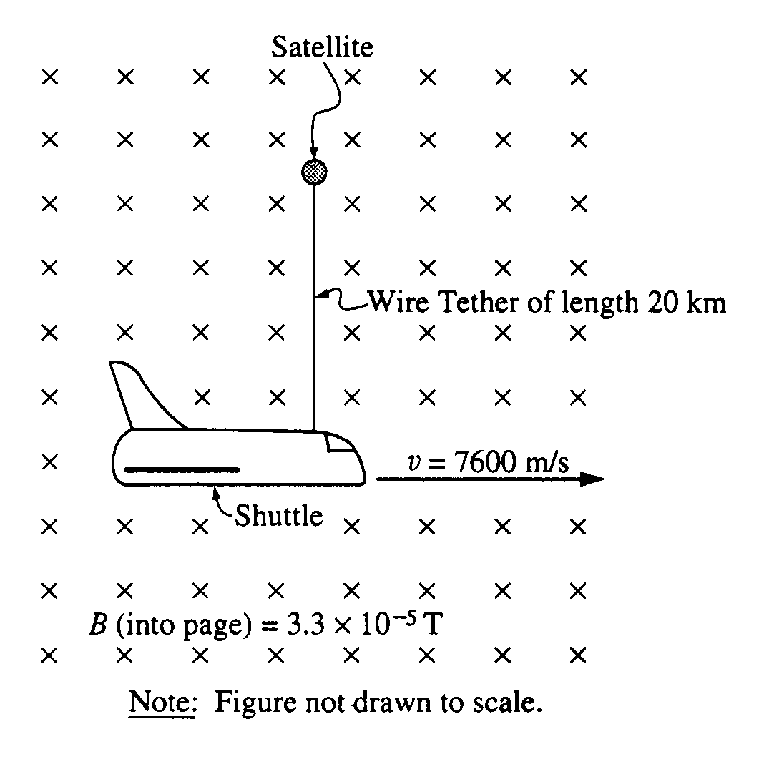
1994E2. One of the space shuttle missions attempted to perform an experiment in orbit using a tethered satellite. The satellite was to be released and allowed to rise to a height of 20 kilometers above the shuttle. The tether was a 20-kilometer copper-core wire, thin and light, but extremely strong. The shuttle was in an orbit with speed 7,600 meters per second, which carried it through a region where the magnetic field of the Earth had a magnitude of 3.3 x 10⁻⁵ tesla. For your calculations, assume that the experiment was completed successfully, that the wire is perpendicular to the magnetic field, and that the field is uniform.
a. An emf is generated in the tether.
i. Which end of the tether is negative?
ii. Calculate the magnitude of the emf generated.

To complete the circuit, electrons are sprayed from the object at the negative end of the tether into the ionosphere and other electrons come from the ionosphere to the object at the positive end.
b. If the resistance of the entire circuit is about 10,000 ohms, calculate the current that flows in the tether.
c. A magnetic force acts on the wire as soon as the current begins to flow.
i. Calculate the magnitude of the force.
ii. State the direction of the force.
d. By how much would the shuttle's orbital energy change if the current remains constant at the value calculated in (b) for a period of 7 days in orbit?
e. Imagine that the astronauts forced a current to flow the other way. What effect would that have, if any, on the orbit of the shuttle? Explain briefly.
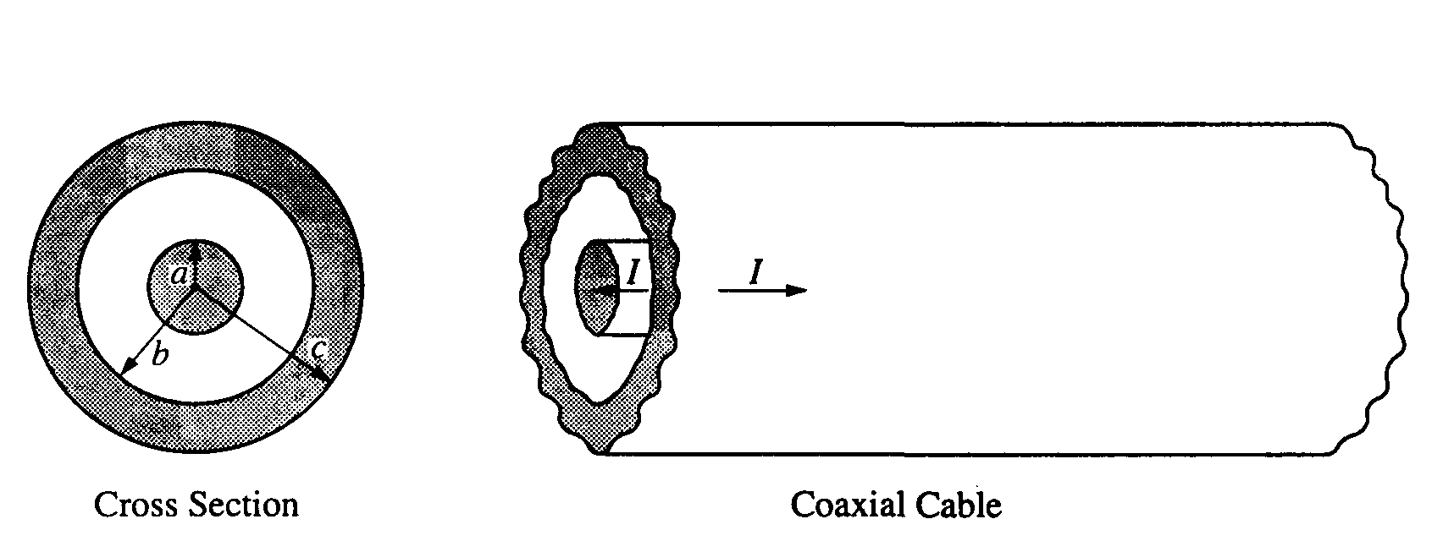

1994E3. A long coaxial cable, a section of which is shown above, consists of a solid cylindrical conductor of radius a, surrounded by a hollow coaxial conductor of inner radius b and outer radius c. The two conductors each carry a uniformly distributed current I, but in opposite directions. The current is to the right in the outer cylinder and to the left in the inner cylinder. Assume μ = μ_{o} for all materials in this problem.
a. Use Ampere's law to determine the magnitude of the magnetic field at a distance r from the axis of the cable in each of the following cases.
i. 0 < r < a ii. a < r < b
b. What is the magnitude of the magnetic field at a distance r = 2c from the axis of the cable?
c. On the axes below, sketch the graph of the magnitude of the magnetic field B as a function of r, for all values of r. You should estimate and draw a reasonable graph for the field between b and c rather than attempting to determine an exact expression for the field in this region.
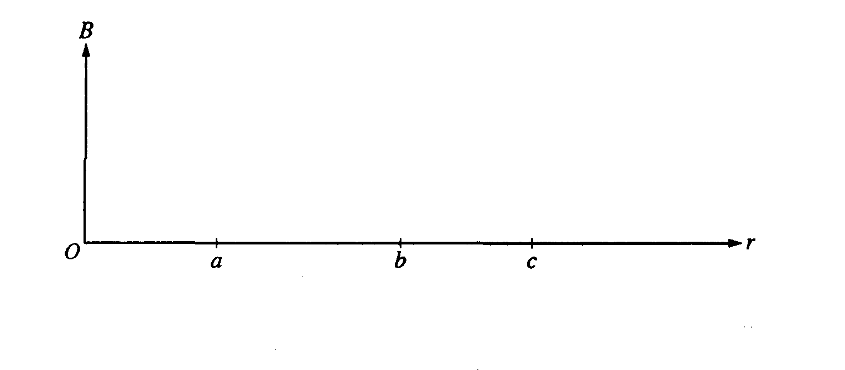
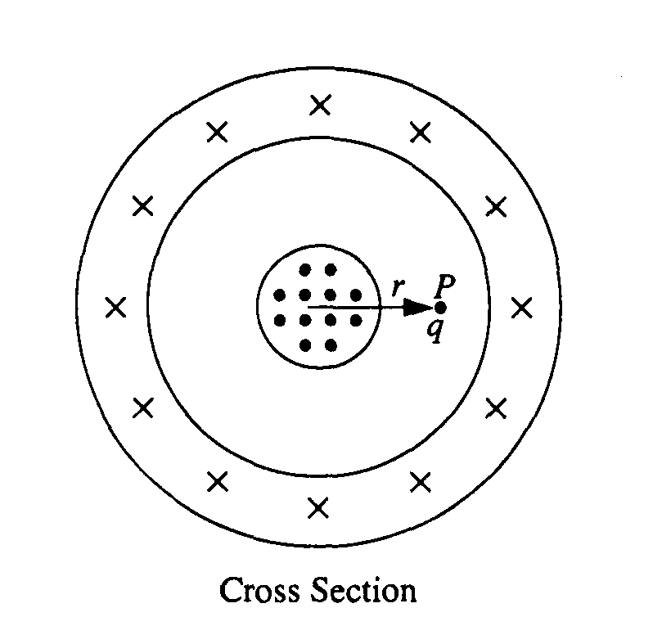
The coaxial cable continues to carry currents I as previously described. In the cross section above, current is directed out of the page toward the reader in the inner cylinder and into the page in the outer cylinder. Point P is located between the inner and outer cylinders, a distance r from the center. A small positive charge q is introduced into the space between the conductors so that when it is at point P its velocity v is directed out of the page, perpendicular to it, and parallel to the axis of the cable.
d. i. Determine the magnitude of the force on the charge q at point P in terms of the given quantities.
ii. Draw an arrow on the diagram at P to indicate the direction of the force.
e. If the current in the outer cylinder were reversed so that it is directed out of the page, how would your answers to (d) change, if at all?

